Week 4 results

Compare graph-based placement and access frequency based placement

# Parameter settings:

Trace file: 120 days file access trace

Edge adding window: 10s

Edge expire window: 1 day

Update period: 1day

Total file count: 90345

Using fixed ssd capacity ratio or fixed ssd capacity to control the data placement instead of using threshold.

# Results comparison:

1. Placement (Number of files on SSD/HDD):

|  |  |  |
| --- | --- | --- |
| Graph based | Access frequency based | Access frequency based (Accumulated) |
|  |  |  |

1. Performance (Number of access from SSD/HDD):

|  |  |  |
| --- | --- | --- |
| Graph based | Access frequency based | Access frequency based (Accumulated) |
|  |  |  |

1. Overhead (Number of file movements):

|  |  |  |
| --- | --- | --- |
| Graph based | Access frequency based | Access frequency based (Accumulated) |
|  |  |  |

# Extended Results

1. Graph mixed with high weight or high access frequency  
   when only use high ssd/hdd ratio, there might be not enough files in SSD. Sometimes, files in SSD may die out.

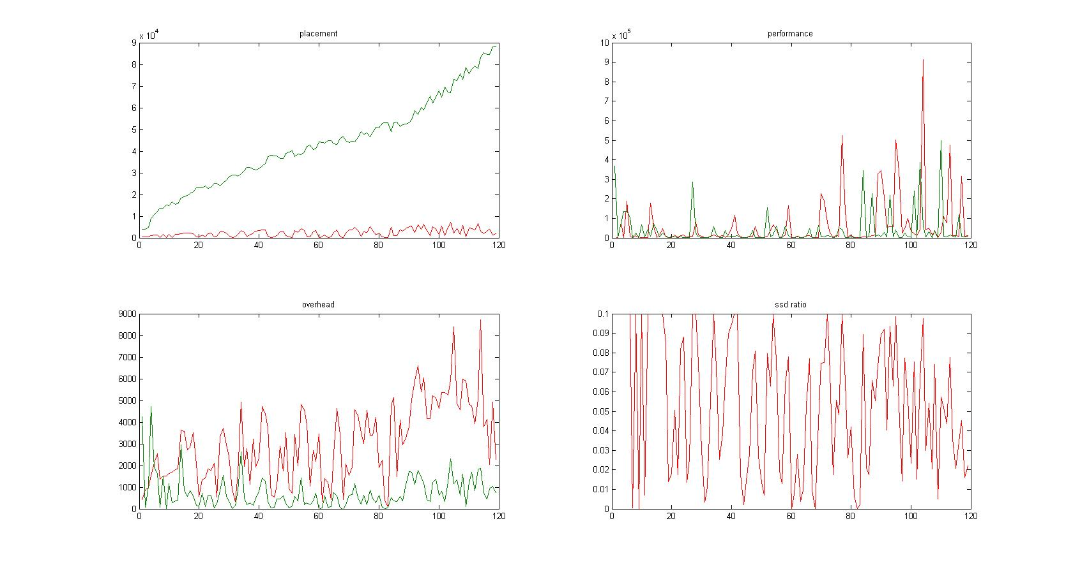

* 1. High weight:

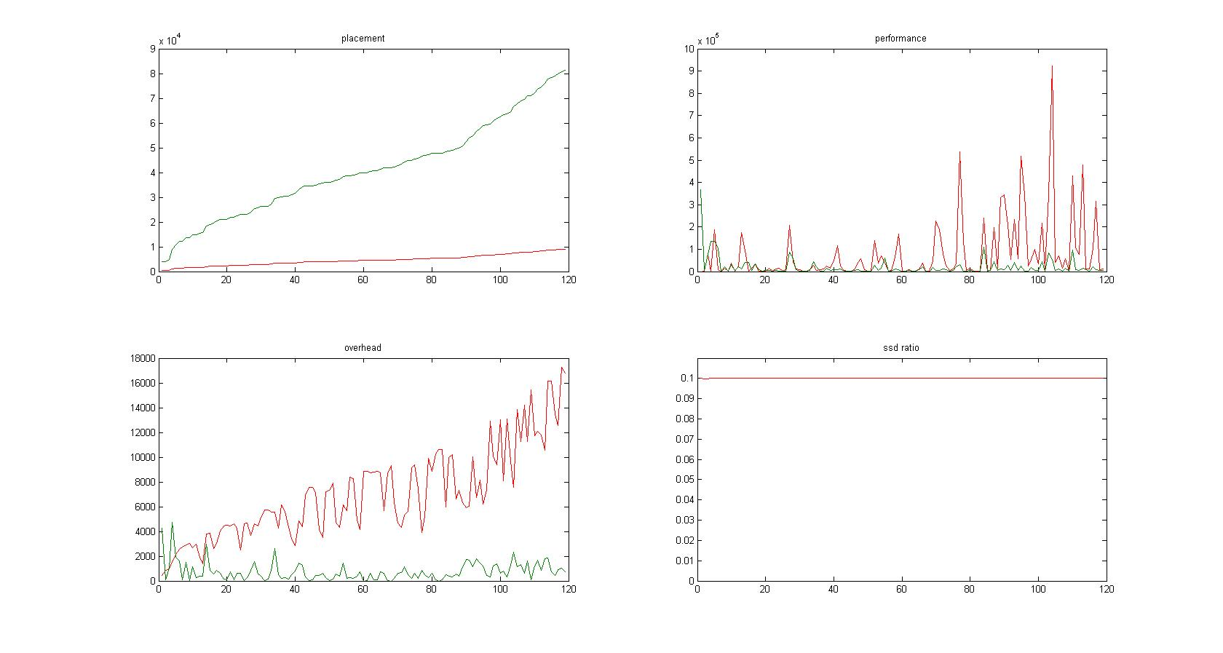

* 1. High access frequency: no help, worse

1. Optimal file movement  
   “If we know 20th day’s access frequency for each file already, how many files do we need to move on 19th day.”

